EXERCISE – 01 (EXPLORATORY DATA ANALYSIS)
1. AIM
To perform Exploratory Data Analysis (EDA) on the Titanic dataset by examining its structure, missing values and statistical summaries, treating the missing data, and visualizing the distributions and relationships between passenger attributes and survival.
2. ALGORITHM
1. Load the Titanic dataset and display its first, last and randomly sampled records.
2. Inspect the shape, data types, descriptive statistics and the number and percentage of missing values; visualize the missing values with a heatmap.
3. Fill the missing Age values with the median, the missing Embarked values with the mode and the missing Cabin values with “Unknown”.
4. Check for duplicate records and remove them.
5. Plot the survival, passenger-class and gender distributions using count plots and a pie chart.
6. Analyze survival against gender, passenger class, fare, and age using count plots, a box plot, a category plot and a scatter plot.
7. Compute the correlation matrix of the numeric columns and display it as a heatmap.
3. PROGRAM
import pandas as pd
import numpy as np
import matplotlib.pyplot as plt
import seaborn as sns
data = 'Dataset/titanic.csv'
df = pd.read_csv(data)
df.head()
df.tail()
df.sample(5)
print("Rows and Columns:", df.shape)
df.info()
df.describe()
df.size
df.columns
df.isnull().sum()
missing_percentage = (df.isnull().sum() / len(df)) * 100
print(missing_percentage.sort_values(ascending=False))
plt.figure(figsize=(10, 6))
sns.heatmap(
df.isnull(),
cbar=False,
yticklabels=False,
cmap="viridis"
)
plt.title("Missing Values Heatmap")
plt.show()
df["Age"] = df["Age"].fillna(df["Age"].median())
df["Embarked"] = df["Embarked"].fillna(df["Embarked"].mode()[0])
df["Cabin"] = df["Cabin"].fillna("Unknown")
print(df.isnull().sum())
print("Number of duplicate rows:", df.duplicated().sum())
df = df.drop_duplicates()
print("Shape after removing duplicates:", df.shape)
plt.figure(figsize=(6, 4))
sns.countplot(data=df, x="Survived")
plt.title("Passenger Survival Count")
plt.xlabel("Survived")
plt.ylabel("Number of Passengers")
plt.show()
survival_counts = df["Survived"].value_counts()
plt.figure(figsize=(6, 6))
plt.pie(
survival_counts,
labels=["Did Not Survive", "Survived"],
autopct="%1.1f%%",
startangle=90
)
plt.title("Survival Distribution")
plt.show()
plt.figure(figsize=(6, 4))
sns.countplot(data=df, x="Pclass")
plt.title("Passenger Class Distribution")
plt.xlabel("Passenger Class")
plt.ylabel("Number of Passengers")
plt.show()
plt.figure(figsize=(6, 4))
sns.countplot(data=df, x="Sex")
plt.title("Gender Distribution")
plt.xlabel("Gender")
plt.ylabel("Number of Passengers")
plt.show()
plt.figure(figsize=(7, 5))
sns.countplot(
data=df,
x="Sex",
hue="Survived"
)
plt.title("Survival by Gender")
plt.xlabel("Gender")
plt.ylabel("Number of Passengers")
plt.show()
plt.figure(figsize=(7, 5))
sns.countplot(
data=df,
x="Pclass",
hue="Survived"
)
plt.title("Survival by Passenger Class")
plt.xlabel("Passenger Class")
plt.ylabel("Number of Passengers")
plt.show()
plt.figure(figsize=(8, 5))
sns.boxplot(
data=df,
x="Survived",
y="Fare"
)
plt.title("Fare Distribution by Survival")
plt.xlabel("Survived")
plt.ylabel("Fare")
plt.show()
g = sns.catplot(
data=df,
x="Pclass",
hue="Survived",
col="Sex",
kind="count",
height=5,
aspect=1
)
g.fig.suptitle(
"Survival by Passenger Class and Gender",
y=1.05
)
plt.show()
plt.figure(figsize=(9, 6))
sns.scatterplot(
data=df,
x="Age",
y="Fare",
hue="Survived",
style="Sex",
size="Pclass",
sizes=(50, 200)
)
plt.title("Age vs Fare by Survival, Gender and Class")
plt.xlabel("Age")
plt.ylabel("Fare")
plt.show()
numeric_columns = [
"Survived",
"Pclass",
"Age",
"SibSp",
"Parch",
"Fare"
]
correlation = df[numeric_columns].corr()
print(correlation)
plt.figure(figsize=(9, 7))
sns.heatmap(
correlation,
annot=True,
cmap="coolwarm",
fmt=".2f",
linewidths=0.5
)
plt.title("Correlation Heatmap")
plt.show()

4. OUTPUT
The program was executed on the Titanic dataset (titanic.csv) and produced the following output:
PassengerId Survived Pclass ... Fare Cabin Embarked
0 1 0 3 ... 7.2500 NaN S
1 2 1 1 ... 71.2833 C85 C
2 3 1 3 ... 7.9250 NaN S
3 4 1 1 ... 53.1000 C123 S
4 5 0 3 ... 8.0500 NaN S
[5 rows x 12 columns]
PassengerId Survived Pclass ... Fare Cabin Embarked
886 887 0 2 ... 13.00 NaN S
887 888 1 1 ... 30.00 B42 S
888 889 0 3 ... 23.45 NaN S
889 890 1 1 ... 30.00 C148 C
890 891 0 3 ... 7.75 NaN Q
[5 rows x 12 columns]
PassengerId Survived Pclass ... Fare Cabin Embarked
474 475 0 3 ... 9.8375 NaN S
248 249 1 1 ... 52.5542 D35 S
226 227 1 2 ... 10.5000 NaN S
127 128 1 3 ... 7.1417 NaN S
438 439 0 1 ... 263.0000 C23 C25 C27 S
[5 rows x 12 columns]
Rows and Columns: (891, 12)
<class 'pandas.core.frame.DataFrame'>
RangeIndex: 891 entries, 0 to 890
Data columns (total 12 columns):
# Column Non-Null Count Dtype
--- ------ -------------- -----
0 PassengerId 891 non-null int64
1 Survived 891 non-null int64
2 Pclass 891 non-null int64
3 Name 891 non-null object
4 Sex 891 non-null object
5 Age 714 non-null float64
6 SibSp 891 non-null int64
7 Parch 891 non-null int64
8 Ticket 891 non-null object
9 Fare 891 non-null float64
10 Cabin 204 non-null object
11 Embarked 889 non-null object
dtypes: float64(2), int64(5), str(5)
memory usage: 83.7 KB
PassengerId Survived Pclass ... SibSp Parch Fare
count 891.000000 891.000000 891.000000 ... 891.000000 891.000000 891.000000
mean 446.000000 0.383838 2.308642 ... 0.523008 0.381594 32.204208
std 257.353842 0.486592 0.836071 ... 1.102743 0.806057 49.693429
min 1.000000 0.000000 1.000000 ... 0.000000 0.000000 0.000000
25% 223.500000 0.000000 2.000000 ... 0.000000 0.000000 7.910400
50% 446.000000 0.000000 3.000000 ... 0.000000 0.000000 14.454200
75% 668.500000 1.000000 3.000000 ... 1.000000 0.000000 31.000000
max 891.000000 1.000000 3.000000 ... 8.000000 6.000000 512.329200
[8 rows x 7 columns]
10692
Index(['PassengerId', 'Survived', 'Pclass', 'Name', 'Sex', 'Age', 'SibSp',
'Parch', 'Ticket', 'Fare', 'Cabin', 'Embarked'],
dtype='object')
PassengerId 0
Survived 0
Pclass 0
Name 0
Sex 0
Age 177
SibSp 0
Parch 0
Ticket 0
Fare 0
Cabin 687
Embarked 2
dtype: int64
Cabin 77.104377
Age 19.865320
Embarked 0.224467
PassengerId 0.000000
Name 0.000000
Pclass 0.000000
Survived 0.000000
Sex 0.000000
Parch 0.000000
SibSp 0.000000
Fare 0.000000
Ticket 0.000000
dtype: float64

PassengerId 0
Survived 0
Pclass 0
Name 0
Sex 0
Age 0
SibSp 0
Parch 0
Ticket 0
Fare 0
Cabin 0
Embarked 0
dtype: int64
Number of duplicate rows: 0
Shape after removing duplicates: (891, 12)

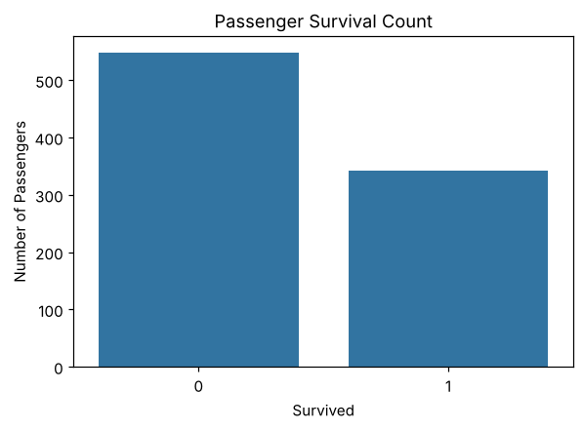
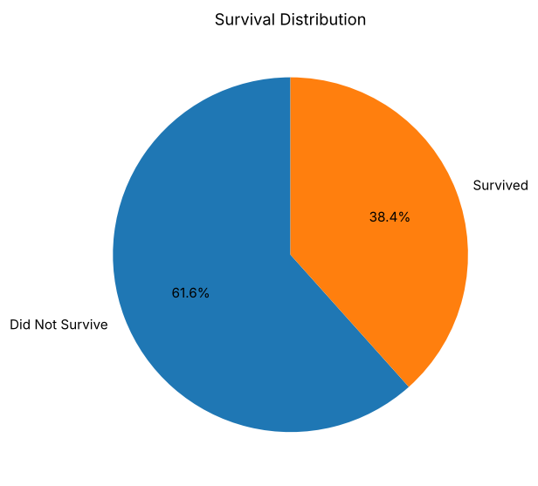
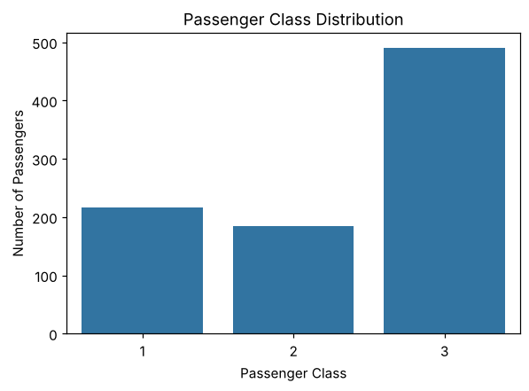
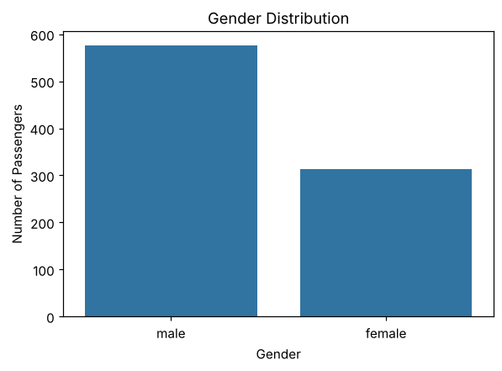
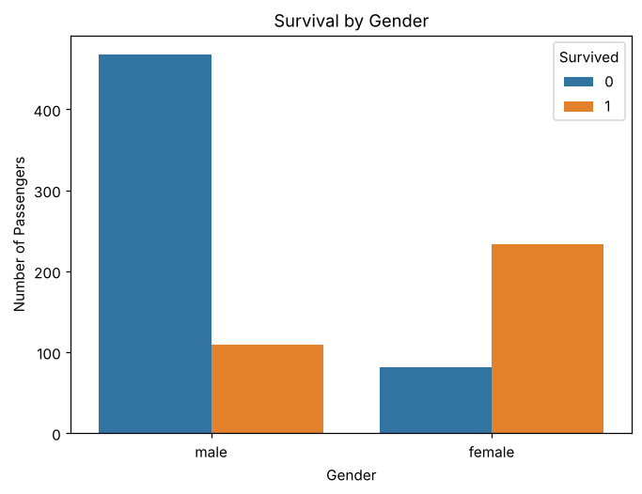
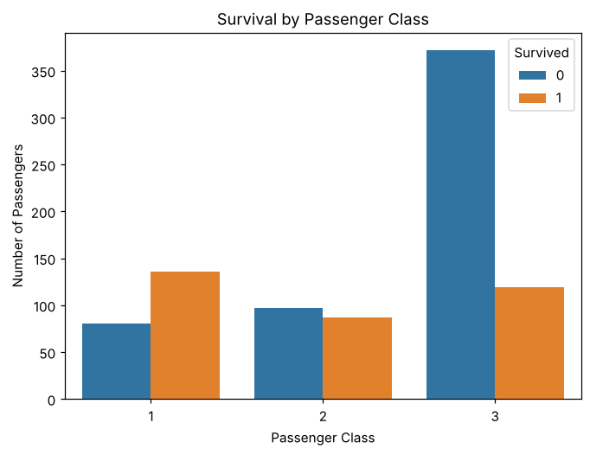
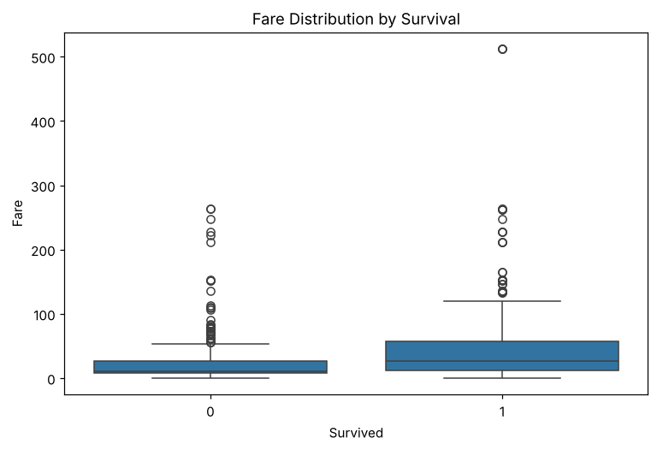
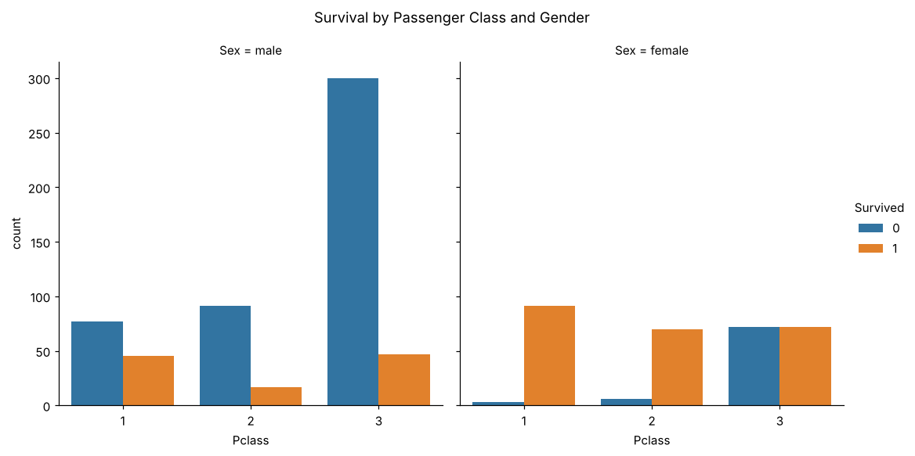
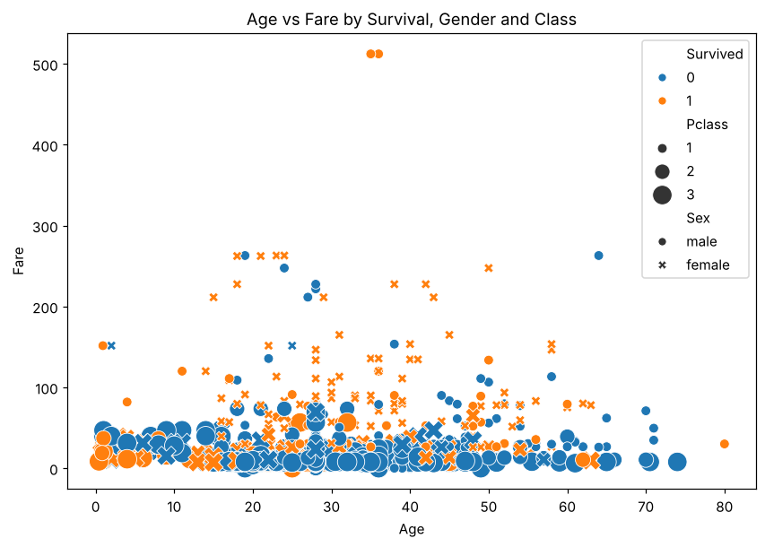
Survived Pclass Age SibSp Parch Fare
Survived 1.000000 -0.338481 -0.064910 -0.035322 0.081629 0.257307
Pclass -0.338481 1.000000 -0.339898 0.083081 0.018443 -0.549500
Age -0.064910 -0.339898 1.000000 -0.233296 -0.172482 0.096688
SibSp -0.035322 0.083081 -0.233296 1.000000 0.414838 0.159651
Parch 0.081629 0.018443 -0.172482 0.414838 1.000000 0.216225
Fare 0.257307 -0.549500 0.096688 0.159651 0.216225 1.000000
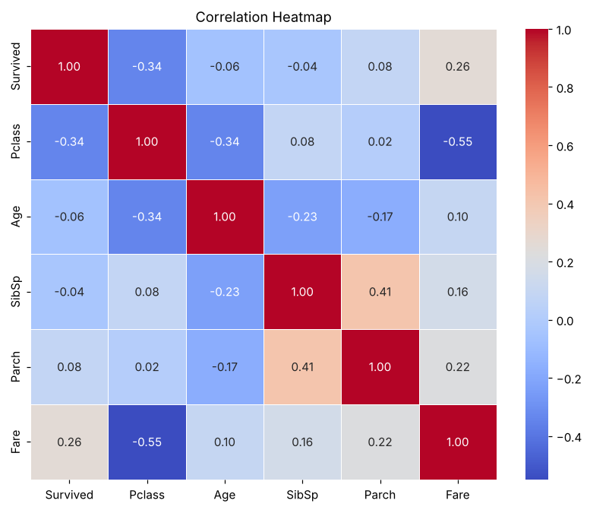

5. RESULT
Thus, the Exploratory Data Analysis on the Titanic dataset was implemented successfully. The dataset contains 891 records and 12 columns. Cabin (77.10%), Age (19.87%) and Embarked (0.22%) had missing values, which were treated, and no duplicate rows were found. Only 38.4% of the passengers survived, and the correlation analysis showed that survival is negatively correlated with passenger class (−0.34) and positively correlated with fare (0.26).

